--- // loops: for (const Rider& rider : riders.getRiders()) …or… for (size_t i = 0; i < songs.size(); ++i) …or… while (var === 1)
--- // c-style arrays: double a[15];
--- // char array has last character as null character: char h[]: {‘H’, ‘i’, ‘\0’}; …or… char h[] “Hi”;
--- // cast c-style string to c++-style string: std::string newCppString(originalCstyleString);
--- // convert c++-style string to c-style string: newCstyleString = originalCppStylestring.c_str();
--- // reference variables with &
--- // create vector: std::vector<int> newVector; …or… std::vector<int> newVector{}; …or… std::vector<int> newVector = {};
--- // create and initiate vector of 100 values, all <double>3.14: std::vector<double> newVector(100, 3.14);
--- // create and initiate vector of 100 values, but empty items: std::vector<double> newVector(100);
--- // push to vector: newVector.push_back(item);
--- // copy vector: std::vector<double> newVector(oldVector);
--- // convert char or string to int, requires cstdlib: int atoi(someCharOrString); // “1234” -> 1234
--- // size_t casts from into to someString.length() equivalent
--- // remove part from string: someString.erase(0, 2); // “string” -> “ing”
--- // get attribute if private: someThing->attribute;
--- // add to int: someInt += 20;
--- // remove from int: someInt -= 20;
--- // pass by value to not change original variable: void function(int originalVariable) { … };
--- // pass by value to change original variable: void function(int &originalVariable) { … };
--- // if substring not found in string: someString.find("someSubstring") != std::string::npos
--- // size of vector, number of items in vector: someVector.size();
--- // if vector is empty: someVector.empty();
--- // remove last element in vector: someVector.pop_back();
--- // empties the vector: someVector.clear();
--- // insert into vector at start: someVector.insert(someVector.begin(), newValueToInsert); // [1] -> [newValueToInsert, 1]
--- // insert into vector at start position: someVector.insert(someVector.begin() + 1, newValueToInsert); // [1, 2] -> [1, newValueToInsert, 2]
--- // insert into vector at end position: someVector.insert(someVector.end(), 2, newValueToInsert); // [1] -> [1, newValueToInsert, newValueToInsert]
--- // remove item from vector: someVector.erase(someVector.begin() + 2); // [1, 2, 3, 4] -> [1, 2, 4]
--- // remove range of items from vector: someVector.erase(someVector.begin() + 1, someVector.begin + 2); // [1, 2, 3, 4] -> [1, 4]
--- // remove range of items from vector: someVector.erase(someVector.begin() + 1, someVector.begin + 2); // [1, 2, 3, 4] -> [1, 4]
--- // get first element of vector: someVector.front();
--- // get last element of vector: someVector.back();
--- // initialize array: int someArray[3] = {1, 2, 3};
--- // sort array: std::sort(someArray, endIndex); e.g. std::sort({2, 1, 3}, 2); // {2, 1, 3} -> {1, 2, 3}
--- // use private variables and getter functions
--- // null pointers: NULL or nullptr e.g. if ( somePointer != NULL ) cout << *somePointer << endl;
--- // use -> for pointers and . for non-pointers
--- // new moves from stack to heap, declaring a pointer
--- // declare pointer: int *somePointer; …or… int *somePointer = new int;
--- // declare multiple pointers: int *somePointer = new int[3];
--- // clean up pointer: delete somePointer;
--- // clean up multiple pointers: delete[] somePointer;
--- // O(1), a.k.a. CONSTANT: The number of operations is independent of the size of the problem. e.g., compute quadratic root.
--- // O(log n), a.k.a. LOGARITHMIC. e.g., dictionary lookup, binary search.
--- // O(n), a.k.a. LINEAR. e.g., sum up a list.
--- // O(n log n), e.g., sorting.
--- // O(n²), O(n³), O(n^{k}), a.k.a. POLYNOMIAL. e.g., find closest pair of points.
--- // O(2^{n}), O(k^{n}), a.k.a. EXPONENTIAL. e.g., Fibonacci, playing chess.
Complexity | Description | Example Code
O(1) | Constant Time | int getFirstElement(int arr[]) { return arr[0]; }
O(log n) | Logarithmic Time | int binarySearch(int arr[], int target) { /* binary search logic */ }
O(n) | Linear Time | int sumArray(int arr[], int size) { int sum = 0; for (int i = 0; i < size; i++) sum += arr[i]; return sum; }
O(n log n) | Linearithmic Time | void mergeSort(int arr[], int left, int right) { /* merge sort logic */ }
O(n^2) | Quadratic Time | void bubbleSort(int arr[], int size) { for (int i = 0; i < size - 1; i++) { for (int j = 0; j < size - i - 1; j++) { if (arr[j] > arr[j + 1]) swap(arr[j], arr[j + 1]); } } }
O(2^n) | Exponential Time | int fibonacci(int n) { if (n <= 1) return n; return fibonacci(n - 1) + fibonacci(n - 2); }
O(n!) | Factorial Time | void permute(string str, int l, int r) { /* permutation logic */ }

--- // find roots of quadratic polynomial
#include <iostream> <cmath> <cstdlib> <string> <vector> <fstream> <algorithm>
bool check_root(int a, int b, int c, float root) {
float check = a * root * root + b * root + c;
if (fabs(check) <= 0.0001) return true;
std::cerr << "ERROR: " << root << " is not a root of this formula." << std::endl; // Console error
return false;
}
bool find_roots(int a, int b, int c, float &root_pos, float &root_neg) {
int radical = b*b - 4*a*c;
if (radical < 0) {
std::cerr << "ERROR: Imaginary roots" << std::endl;
return false;
}
float sqrt_radical = sqrt(radical);
root_pos = (-b + sqrt_radical) / float(2*a);
root_neg = (-b - sqrt_radical) / float(2*a);
return true;
}
int main(int argc, char* argv[]) {
if (argc != 4) {
std::cerr << "Usage: " << argv[0] << " <a> <b> <c>" << std::endl;
return 1; // Error
}
int my_a = std::atoi(argv[1]); // Get arg
int my_b = std::atoi(argv[2]);
int my_c = std::atoi(argv[3]);
if (my_a == 0) {
std::cerr << "ERROR: 'a' cannot be zero in a quadratic function." << std::endl;
return 1;
}
float root_1, root_2;
bool success = find_roots(my_a, my_b, my_c, root_1, root_2);
if (!success) return 1;
std::cout << "The roots are: " << root_1 << " and " << root_2 << std::endl; // Console log
if (check_root(my_a, my_b, my_c, root_1) && check_root(my_a, my_b, my_c, root_2)) {
std::cout << "Verification successful." << std::endl;
} else {
std::cerr << "ERROR: Unable to verify one or both roots." << std::endl;
return 1;
}
return 0; // No error
}

--- // .h file
#ifndef RIDER_H // must be unique
#define RIDER_H // must be unique
#include <string>
struct Rider {
bool exists = false; // initial value
std::string firstName;
double pickupLatitude;
int someInteger;
};
class Drivers {
private:
std::vector<Driver> drivers = {};
public:
Drivers(const std::string& driversFileName);
std::vector<Driver> getDrivers() const&; // const& passes large objects without copying, while const creates separate copy
std::vector<Driver> updateDriver(const Driver& updatedDrivers);
void someVoidFunction;
~Drivers(); // Destructor runs when object is destroyed
};
#endif

--- // corresponding .cpp file
#include "Drivers.h" <fstream> <iostream> <string> <vector> "Driver.h"
Drivers::Drivers(const std::string& driversFileName) {
std::ifstream driversFile(driversFileName);
if (!driversFile.is_open()) {
std::cerr << "Failed to open the drivers file." << std::endl;
exit(1);
}
std::string line;
while (getline(driversFile, line)) {
int nextSpaceFound = line.find(" ");
std::vector<std::string> driverAttributes;
driverAttributes.push_back(line.substr(0, nextSpaceFound));
while (line.find(" ") != std::string::npos) {
line.erase(0, nextSpaceFound + 1);
nextSpaceFound = line.find(" ");
if ((size_t)nextSpaceFound == std::string::npos) nextSpaceFound = line.length();
driverAttributes.push_back(line.substr(0, nextSpaceFound));
}
Driver newDriver;
newDriver.exists = true;
newDriver.firstName = driverAttributes[0];
drivers.push_back(newDriver);
}
// Testing - check to see if everything was added to the vector correctly
// for (const Driver& driver : drivers) std::cout << "Debug: Driver - " << driver.firstName << " " << driver.lastName << " ... " << driver.currentRiderPhoneNumber << std::endl;
driversFile.close();
}
std::vector<Driver> Drivers::getDrivers() const& { // Getter function, returns an std::vector<Driver>
return drivers;
}
std::vector<Driver> Drivers::updateDriver(const Driver& updatedDriver) { // Setter function
for (size_t i = 0; i < drivers.size(); i++) {
if (drivers[i].phoneNumber == updatedDriver.phoneNumber) {
drivers[i] = updatedDriver;
break;
}
}
return drivers;
}
void Drivers::someVoidFunction() { int oneInt = 1 } // void function with no return
Drivers::~Drivers() { } // Destructor, no return type, no params, runs when program exits or vector of objects is destroyed or object goes out of scope

--- // overload output operator to use cout multiple lines easily
std::ostream& operator<<(std::ostream& os, const City& c) {
os << c.name << ", " << c.state << " [Rent: $" << c.rent << "k" << ", QoL Score: " << c.qualityOfLife() << "]";
return os;
}

--- // usage of null pointers and pointers
int main() {
std::cout << "City Quality of Life Comparison:\n";
const int NUM_CITIES = 4;
// ------------------ 1D ARRAY OF CITY OBJECTS ------------------
City cities[NUM_CITIES] = {
City("Troy", "NY", 0.9, 6, 4),
City("New York City", "NY", 4.0, 6, 9),
City("Newark", "NJ", 3.0, 7, 6),
City("Baltimore", "MD", 1.5, -2, 5)
};
// ------------------ POINTER ARITHMETIC TRAVERSAL ------------------
City* cityPtr = cities; // pointer to first element
City* bestCity = nullptr; // NULL pointer example
double bestScore = -1e9;
std::cout << "\n--- Traversing cities using pointer arithmetic ---\n";
for (int i = 0; i < NUM_CITIES; i++) {
City* current = cityPtr + i; // pointer arithmetic
current->print();
if (bestCity == nullptr || current->qualityOfLife() > bestScore) {
bestCity = current;
bestScore = current->qualityOfLife();
}
}
// ------------------ NULL POINTER CHECK ------------------
std::cout << "\n--- Result ---\n";
if (bestCity != nullptr) {
std::cout << "Best city: " << bestCity->getName() << "\n";
} else {
std::cout << "No cities evaluated.\n";
}
// ------------------ RAW ARRAY OF QoL SCORES + SORTING ------------------
double qolArray[NUM_CITIES];
for (int i = 0; i < NUM_CITIES; i++) qolArray[i] = cities[i].qualityOfLife();
std::cout << "\nQoL scores before sorting:\n";
for (int i = 0; i < NUM_CITIES; i++) std::cout << qolArray[i] << " ";
std::cout << "\n";
std::sort(qolArray, qolArray + NUM_CITIES);
std::cout << "\nQoL scores after sorting:\n";
for (int i = 0; i < NUM_CITIES; i++) std::cout << qolArray[i] << " ";
std::cout << "\n";
// ------------------ 2D ARRAY: RAW METRICS TABLE ------------------
// Columns: [Rent, Safety, Traffic, QoL]
const int NUM_METRICS = 4;
double table[NUM_CITIES][NUM_METRICS];
for (int i = 0; i < NUM_CITIES; i++) {
City* c = cityPtr + i;
table[i][0] = c->getRent();
table[i][1] = c->getSafety();
table[i][2] = c->getTraffic();
table[i][3] = c->qualityOfLife();
}
std::cout << "\n--- 2D Table of City Metrics ---\n";
std::cout << "City | Rent | Safety | Traffic | QoL\n";
for (int i = 0; i < NUM_CITIES; i++) {
std::cout << cities[i].getName() << " | "
<< table[i][0] << " | "
<< table[i][1] << " | "
<< table[i][2] << " | "
<< table[i][3] << "\n";
}
return 0;
}

--- // pointers
float x=5, y=9;
float *p = &x, *q = &y;
*p = 17.0;
*q = *p;
q = p;
*q = 13.0;

--- // usage of -> or .
class MyClass {
public:
void display() { std::cout << "Hello World!" << std::endl; }
};
int main() {
MyClass obj;
obj.display(); // Accessing member using .
return 0;
} // …or using pointers…
int main() {
MyClass* objPtr = new MyClass();
objPtr->display(); // Accessing member using ->
delete objPtr; // Remember to free memory
return 0;
}

--- // friends
void printWidth(Box box) { cout << "Width of box: " << box.width << endl; } // Generic function
class Box {
double width;
public:
friend void printWidth(Box box);
void setWidth(double wid);
};

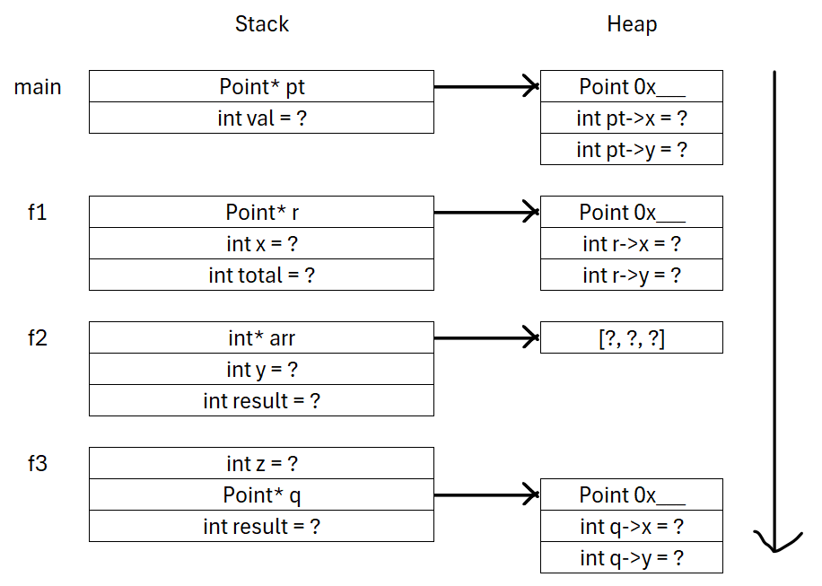
--- // stack-heap diagram
#include <iostream> <cstdlib> // for rand() <ctime> // for time()
struct Point {
int x;
int y;
};
int f3(Point* p) {
int z = rand() % 100 + 1; // 1..100
Point* q = new Point{rand() % 50, rand() % 50}; // new dynamic Point
std::cout << "In f3, z = " << z << ", q->x = " << q->x << ", q->y = " << q->y << "\n";
p->x += z; // modify main Point
int result = z + p->y + q->x; // use heap object
delete q; // free heap memory
return result;
}
int f2(Point* p) {
int y = rand() % 50 + 1; // 1..50
int* arr = new int[3]{rand() % 10, rand() % 10, rand() % 10}; // dynamic array
int result = f3(p) + arr[1];
delete[] arr; // free array
std::cout << "In f2, sum = " << result + y << "\n";
return result + y;
}
int f1(Point* p) {
int x = rand() % 20 + 1; // 1..20
Point* r = new Point{rand() % 5, rand() % 5};
int total = f2(p) + x + p->x + r->y;
delete r; // free heap object
std::cout << "In f1, total = " << total << "\n";
return total;
}
int main() {
std::srand(std::time(nullptr)); // seed random generator
Point* pt = new Point{rand() % 10, rand() % 10}; // randomized Point
int val = f1(pt) + pt->y;
std::cout << "In main, val = " << val << "\n";
delete pt;
return 0;
}

